Cell Structure
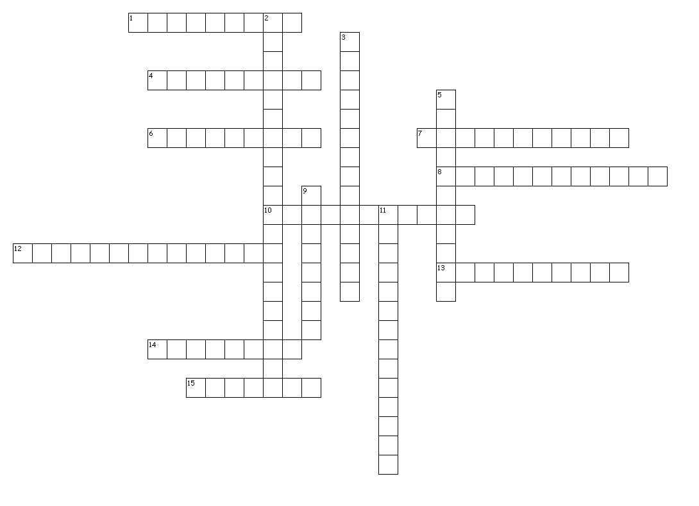
Across
1. Responsible for making protein
4. Main component of the cell wall
6. Jelly-like substance inside cells
7. Organisms who lack a true nucleus
8. Convert carbohydrates to ATP
10. Carries out photosynthesis
12. Stores water & waste in plants
13. Have a nucleus and organelles
14. Rigid outer layer of plant cells
15. Circular chromosome in prokaryotes
Down
2. Intracellular highway
3. Packing & distribution center
5. Condensed DNA in the nucleus
9. Whip-like structure used for moving
11. Lipid bilayer surrounding cell

